**Prototype 1: Candy Pop**

**If you want to change anything please notify the group first before making any drastic changes, if no one responds immediately, put it down on a separate word doc with the allocated number next to it**

1. **Introduction**

This Design Document will highlight the aims and overarching guideline of prototype one, ‘Candy Pop’. Where it will discuss the appropriate development choices in both the mechanical and aesthetical sense.

* 1. **Scope**

This document is aimed at programmers and designers in recreating or further developing ‘Candy Pop’.

1. **Game Overview**
   1. **Game Concept**

‘Candy Pop’ is a 2D single-player game where the player shoots candy from a cannon set on the base of a rectangular level. Within the level, there will be multiple candies floating within the rectangle. The objective of the game is to shoot the players current candy colour they have towards the floating candies of the same colour, thus popping them, ultimately destroying all of them. However, if the player shoots towards candies of different colours, they will not pop but instead stick on and add towards the floating candies.

* 1. **Genre**

The genre of the game is an 32bit arcade style puzzle game that is inspired by games such as bubble pop, candy crush and Game Boy Advance or old mobile games.

* 1. **Target Audience**

The game is mainly aimed towards children within the ages of 9 and above, mainly used as a source of entertainment for parents to give to children.

* 1. **Game Flow Summary**

When the player opens the game they will be introduced to a colourful menu where they can use their mouse to click on the start button, this is done as the game only requires the mouse thus is immediately communicated once the player enters a level as they will still be using the mouse. Within the level, they player will be given a simple design of the ‘floating candies’ or puzzle, this done for the purpose of giving the player a tutorial level. Once the player has finished the tutorial level they will be congratulated and sent to the next level. Each level progressively increasing in difficulty.

Level Flow

* + 1. Tutorial
    2. Level 1
    3. Level 3
  1. Look and Feel

1. **Gameplay and Mechanics**
   1. Figure 1 displays the basic layout of what a level will look like within ‘Candy Pop’. Within the figure we can see both the mechanical aspects such as the cannon, aiming tool and bubbles and where they will be positioned, as well as an early design of where the visual aesthetics may be placed such as the player avatar.
   2. Figure 2 displays the basic layout of tutorial level. This level is designed to introduce pattern recognition through colours as well as teach the player the mechanics of the game.
   3. Figure 3 displays the level the player will see once the player completes the tutorial level. This level is designed to demonstrate complexity within the mechanics shown within the first level as well as introduce a new mechanic of bombs. Furthermore, it introduces the dynamic of using the walls to reflect the shot into a new angle. Lastly, within the last part of the level, if the player shoots a bubble in the right spot, they will be given a satisfying chain reaction of bubbles popping. This reinforces the idea players needing to think about where they are shooting if they want to recreate moments like that.
   4. Figure 4 is an example of future designs that can be implemented within the game. The example begins to introduce the idea of the player timing their shots instead of simply shooting at random intervals.

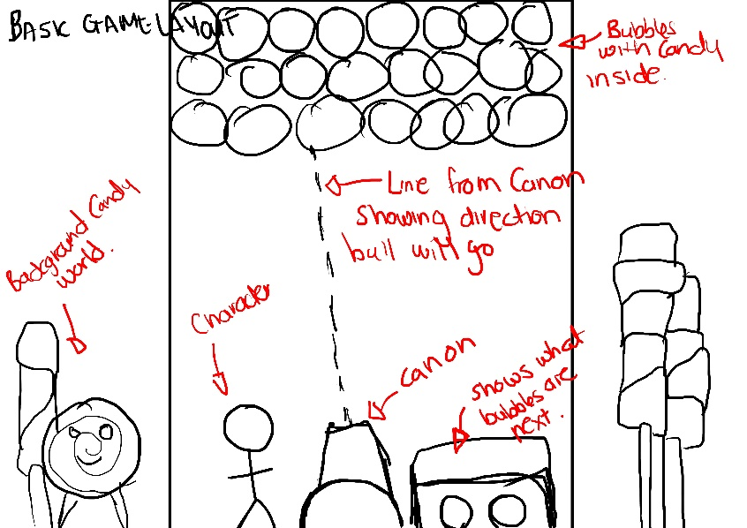

**Figure 1**

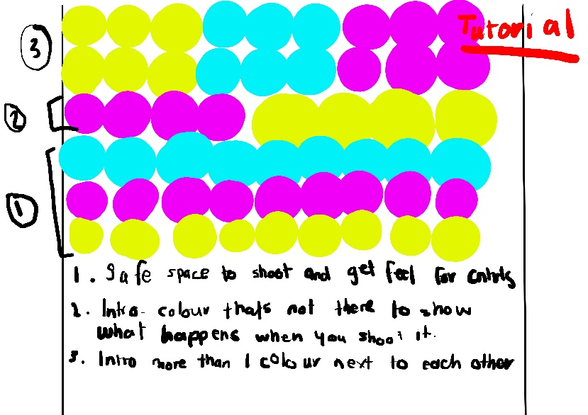

**Figure 2**

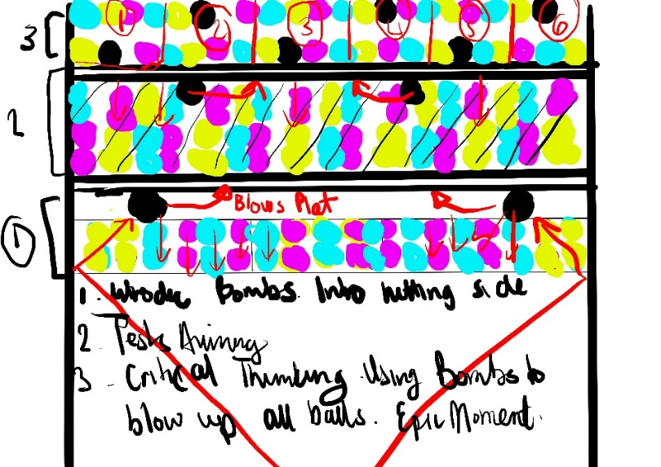

**Figure 3**

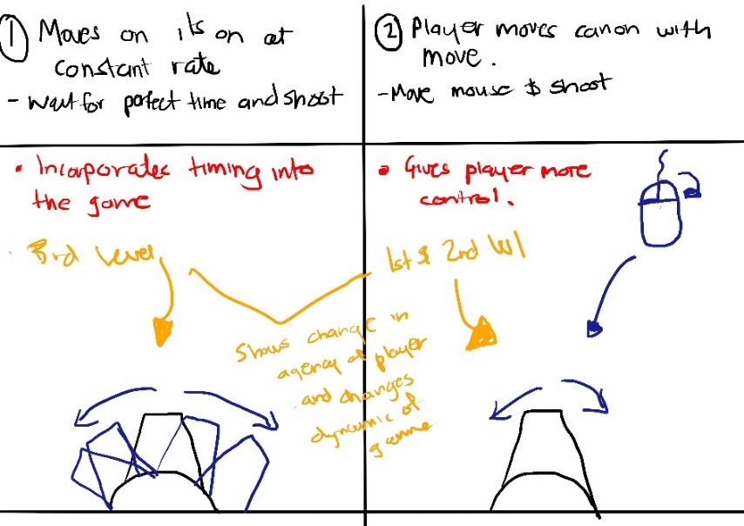

**Figure 4**

**Minutes**

23rd July:

Concept :

Build a game where we shoot bullets, matching colours, when match.

Theme:

Bubble pop game that appeals to kids

Food, colourful, 8bit

Sound 8 bit, nostalgic

Genre:

Arcade

How do we polish the game:

Sound

The game is about how to get the right feel, needs a lot of playtesting

Need to work close with sound, design and general feel, how fast the ball is moving, how does it pop

**Deadline 1:**

**24th July**

* **Nathi: Shoot Mechanic, Match Mechanic**
* **Lucky: Right combination, death, win, background sound**
* **Ryan: Ammo loading, popping chains, aiming with mouse**
* **Nicole: 3 prototypes, player**
* **Wednesday: Format & level design**

24th July:

Completed

Resolving split of work, currently Nathi has the spawn generation but doesn’t have the shooting working

Ryan completed the reloading mechanic

Wednesday finished the design of three levels, need to implement the designs into the design doc

Lucky implemented the sounds, pop, shoot, death

Nicole completed three sets of different candies and the player

**Menu Design**

**Deadline 2:**

**Nathi – Shoot mechanic and cannon w/ Ryan**

**Ryan – Chain mechanic**

**Wednesday- UI and UX design draft**

**Nicole – Bomb, cannon, counter predict bar**

**Lucky – Finishing the sound, see in doc,**

**Mechanics :**

Need to redistribute work(Work in progress)

Cannon/Player

* Shooting
* Aiming with mouse
* Aiming line

World

* Bubble pop when in a set(For now just make it a set of 3)
* Ball bouncing on wall(Up and away from the wall)
* Level Change when all candies are popped
* Instantiating set of levels each beginning(Tutorial, 1st , second, etc)

UI

* Main menu(Start button, Controls, Credits)
* Next shot colour

**Only start doing this when all of the above is complete**

* Different effects of each set popping (Speak with designer to see what abilities would best fit)

**Aesthetics:**

Please don’t forget to communicate with each other (Sound, Art and Designer) to make sure our aesthetics align with one another.

Art

* Cannon/ Character (Perhaps a small idle animation for the character)
* Different candies
* Background (Main menu, One for each level) Need to discuss design of level
* Border of the container
* Speech bubbles on success (Please speak with programmers to see how to implement)
* Animation of popped bubble
* Fonts(Speak with designer)
* Victory sign / Failed sign

Sound

* Bubble pop
* Background music
* Matching the bubbles (Maybe like a small yay, need to speak with designer)
* Failed Level
* Level Success
* Cannon shooting sound
* Bubble bounce on wall sound

Amount of Assets needed: